Hamza
24k-3065
Lab-12

Q2:
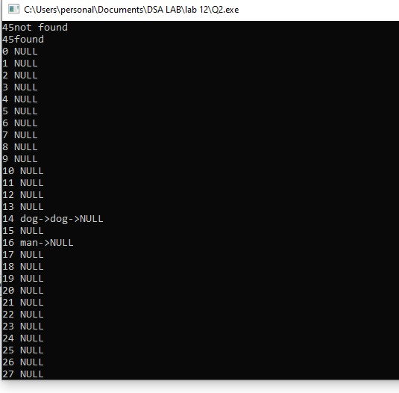
#include <iostream>
#include <string>
using namespace std;
class Node{
public:
string data;
Node *next;

Node (string d){
next=NULL; data=d;
}
};

class seaparate_chaining{
public:
Node **arr; int size; int entries;

seaparate_chaining(){
size=100;
arr=new Node* [size]; for(int i=0;i<size;i++){
arr[i]=NULL;
}
entries=0;
}

int hash(string s){
int n=0;

for(int i=0;i<s.length();i++){
n=n+(int)s[i];
}

return (n%size);
}

void insert(string n){ float lf=(float)entries/(float)size;
int key=hash(n);
Node *newnode=new Node(n);

if(lf<0.7){ if(arr[key]==NULL){ arr[key]=newnode;
}else{
Node *temp=arr[key]; while(temp->next!=NULL){
temp=temp->next;
}
temp->next=newnode;
}
entries++; }else{ rehashing();
insert(n);
}
}

void rehashing(){
Node **temp=arr;
int old_size=size;
entries=0; size*=2;
arr=new Node *[size]; for(int i=0;i<size;i++){
arr[i]=NULL;
}
for(int i=0;i<old_size;i++){
Node *t=temp[i]; while(t!=NULL){ insert(t->data); t=t->next;
}
}

delete []temp;
}

Node* search(string s){
int key =hash(s);
cout<<key;
Node *temp=arr[key];

while(temp!=NULL){ if(temp->data==s){
cout<<"found "; return temp;
}
temp=temp->next;
}
cout<<"not found"; return temp;
}

void display(){ for(int i=0;i<size;i++){
Node *temp=arr[i]; cout<< i<<" "; while(temp!=NULL){ cout<<temp->data<<"->"; temp=temp->next;

}

cout<<"NULL\n";

}
}

};

int main(){ seaparate_chaining s;
s.insert("dog");
s.insert("horse");
s.insert("mouse");
s.insert("man");
s.insert("dog");
s.insert("horse");
s.search("sss"); cout<<endl;
s.search("horse"); cout<<endl;
s.display();
}
Q4:

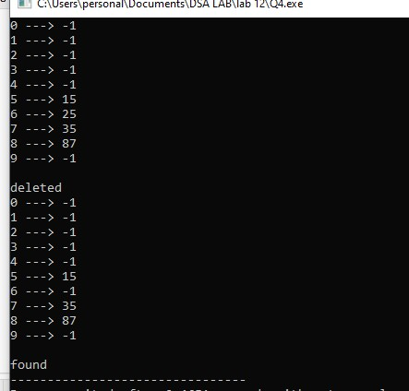
#include <iostream> using namespace std; class linear_probing{
public: int *arr; int size; int entries;

linear_probing(){
size=10;
arr=new int[size]; for(int i=0;i<size;i++){
arr[i]=-1;
}
entries=0;
}
int hash(int n){ return (n%size);
}
void search(int n){
int key=hash(n); if(arr[key]==n){ cout<<"\nfound";

return;
}
int i=key+1;

while(true){
if(key==i){ cout<<"\nnot found";
return;
}
if(arr[i]==n){ cout<<"\nfound"; return;
}
i=(i+1)%size;

}
}

void insert(int n){ float lf=(float)entries/size;
int i=0;
bool flag=true;

while(flag){

int key=(hash(n)+i)%size;
if(lf<0.7){ if(arr[key]==-1){
arr[key]=n; entries++; return;
}

}
i=(i+1)%size;
}
rehashing();
insert(n);
}

void rehashing(){
int *temp=arr; int old_size=size;
size*=2;
arr=new int[size]; for(int i=0;i<size;i++){
arr[i]=-1;
}
for(int i=0;i<old_size;i++){ if(temp[i]!=-1)insert(temp[i]);
}
}

void delete_probe(int n){
int key=hash(n); if(arr[key]==n){ arr[key]=-1; cout<<"\ndeleted";

return;
}
int i=key+1;

while(true){
if(key==i){ cout<<"\nnot found";
return;
}
if(arr[i]==n){
arr[i]=-1;
cout<<"\ndeleted";
return;
}
i=(i+1)%size;

}
}

void display(){

Q5:

for(int i=0;i<size;i++){ cout<<i<<" ---> "<<arr[i]; cout<<endl;
}
}

};

int main(){
linear_probing l;
l.insert(15);
l.insert(25);
l.insert(35);
l.insert(87);

l.display();
l.delete_probe(25); cout<<endl;
l.display();
l.search(35);
}
Q6:

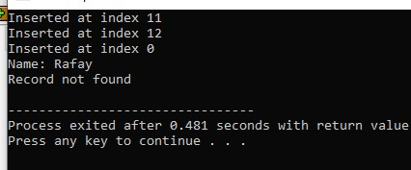
#include <iostream> using namespace std;

struct Student {
int roll;
string name; bool empty; Student() { roll = -1; name = ""; empty = true;
}
};

class StudentHashTable { public: Student *arr; int size;

StudentHashTable() {
size = 15; arr = new Student[size];
}

int hash(int n) { return n % size;
}

void InsertRecord(int roll, string name) { int index = hash(roll);

for(int i = 0; i < size; i++) { int key = (index + i*i) % size;

if(arr[key].empty) { arr[key].roll = roll; arr[key].name = name; arr[key].empty = false; cout << "Inserted at index " << key << endl;
return;
}
}

cout << "Table Full, cannot insert." << endl;
}

void SearchRecord(int roll) { int index = hash(roll);

for(int i = 0; i < size; i++) { int key = (index + i*i) % size;

if(arr[key].empty) { cout << "Record not found" << endl;
return;
}

if(arr[key].roll == roll) { cout << "Name: " << arr[key].name << endl;
return;
}
}

cout << "Record not found" << endl;
}
};

int main() {
StudentHashTable t;

t.InsertRecord(101, "Ali");
t.InsertRecord(116, "Rafay");
t.InsertRecord(131, "Saad");

t.SearchRecord(116);
t.SearchRecord(200);
}
Q5:

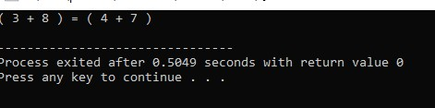
#include <iostream>
#include <string>
using namespace std;

class Node{
public:
string data;
Node *next;

Node (int a,int b){
next=NULL;
data=to_string(a)+" + "+to_string(b);

}
};

class seaparate_chaining{
public:
Node **arr; int size; int entries;

seaparate_chaining(int ar[]){
int max=ar[0];

for(int i=0;i<7;i++){ if(max<ar[i])max=ar[i];
}
size=max+max;
arr=new Node* [size]; for(int i=0;i<size;i++){
arr[i]=NULL;
}
entries=0;
}

int hash(int a,int b){
return (a+b)%size;
}

Node * insert(int a,int b){
int key=hash(a,b);
Node *newnode=new Node(a,b);

if(arr[key]==NULL){ arr[key]=newnode;
}else{
Node *temp=arr[key]; while(temp->next!=NULL){
temp=temp->next;
}
temp->next=newnode;
cout<<"( "<<temp->data<<" )"<<" = ";
return temp->next;
}
entries++;
return NULL;
}

void display(int a[]){
Node *n;
bool flag=true;
for(int i=0;i<7;i++){
for(int j=i+1;j<7;j++){
n=insert(a[i],a[j]); if(n!=NULL){
cout<<"( "<<n->data<<" )"<<endl;
flag=false; return;
}
}
}
if(flag)cout<<"no pair found";
}

};

int main(){
int arr[7]={3,4,7,1,2,9,8};

seaparate_chaining s(arr);
s.display(arr);
//cout<<n->data;
}
Q3:
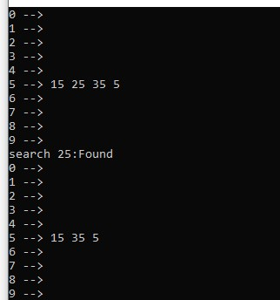
#include <iostream> #include <list> using namespace std;

class Hash { public:
int size; list<int>* table;

Hash(int s) { size = s; table = new list<int>[size];
}

int hashFunction(int key) { return key % size;
}

void insert(int key) { int index = hashFunction(key); table[index].push_back(key);
}

void deleteItem(int key) { int index = hashFunction(key); table[index].remove(key);
}

bool search(int key) { int index = hashFunction(key); for (int x : table[index]) { if (x == key) { return true;
}
}
return false;
}

void display() { for (int i = 0; i < size; i++) { cout << i << " --> "; for (int x : table[i]) { cout << x << " ";
}
cout << endl;
}
}
};

int main() {
Hash h(10);

h.insert(15);
h.insert(25);
h.insert(35);
h.insert(5);

h.display();

cout << "search 25:"<<(h.search(25) ? "Found" : "Not Found") << endl;

h.deleteItem(25);
h.display();

return 0;
}

